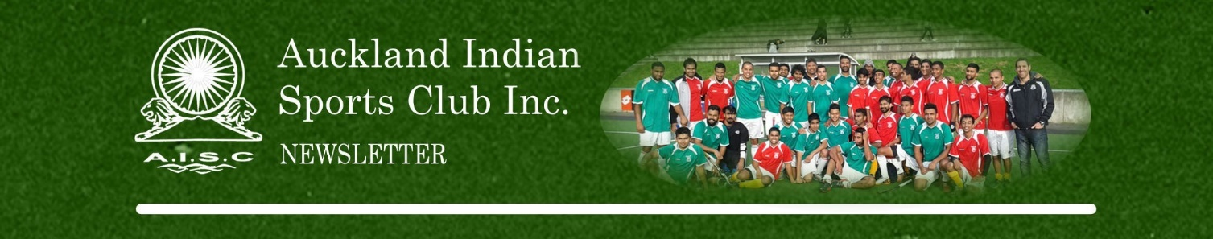

NOTICE OF ANNUAL GENERAL MEETING

Date: Sunday, 19 November, 2023

Venue: Balmoral Bowling Club
14 Mont Le Grand Rd
Mt Eden

From: 3.00pm

ANNUAL GENERAL MEETING AGENDA

1. Apologies
2. Minutes of the last meeting
3. Matters arising from the minutes of the last meeting
4. President’s Report 2023
5. Financial Report 2023 Presentation – Audited
6. Election of Officers
1. President
2. Vice President – Hockey
3. Vice President – Cricket
4. Secretary
5. Assistant Secretary
6. Treasurer
7. Club Captains
8. Portfolio Positions
- Coaching and Development
- Marketing and Promotions
- Participation and Member Services
- Communications
- Finance
7. General Business

Please attend the AGM so that you can have input into the running of the Club. We require a quorum of 20 to proceed, so please do not be late. Please advise Vinod Patel (Mb: (021) 644-013, vbpatel2017@outlook.com) if you wish to have any further General Business discussed.

